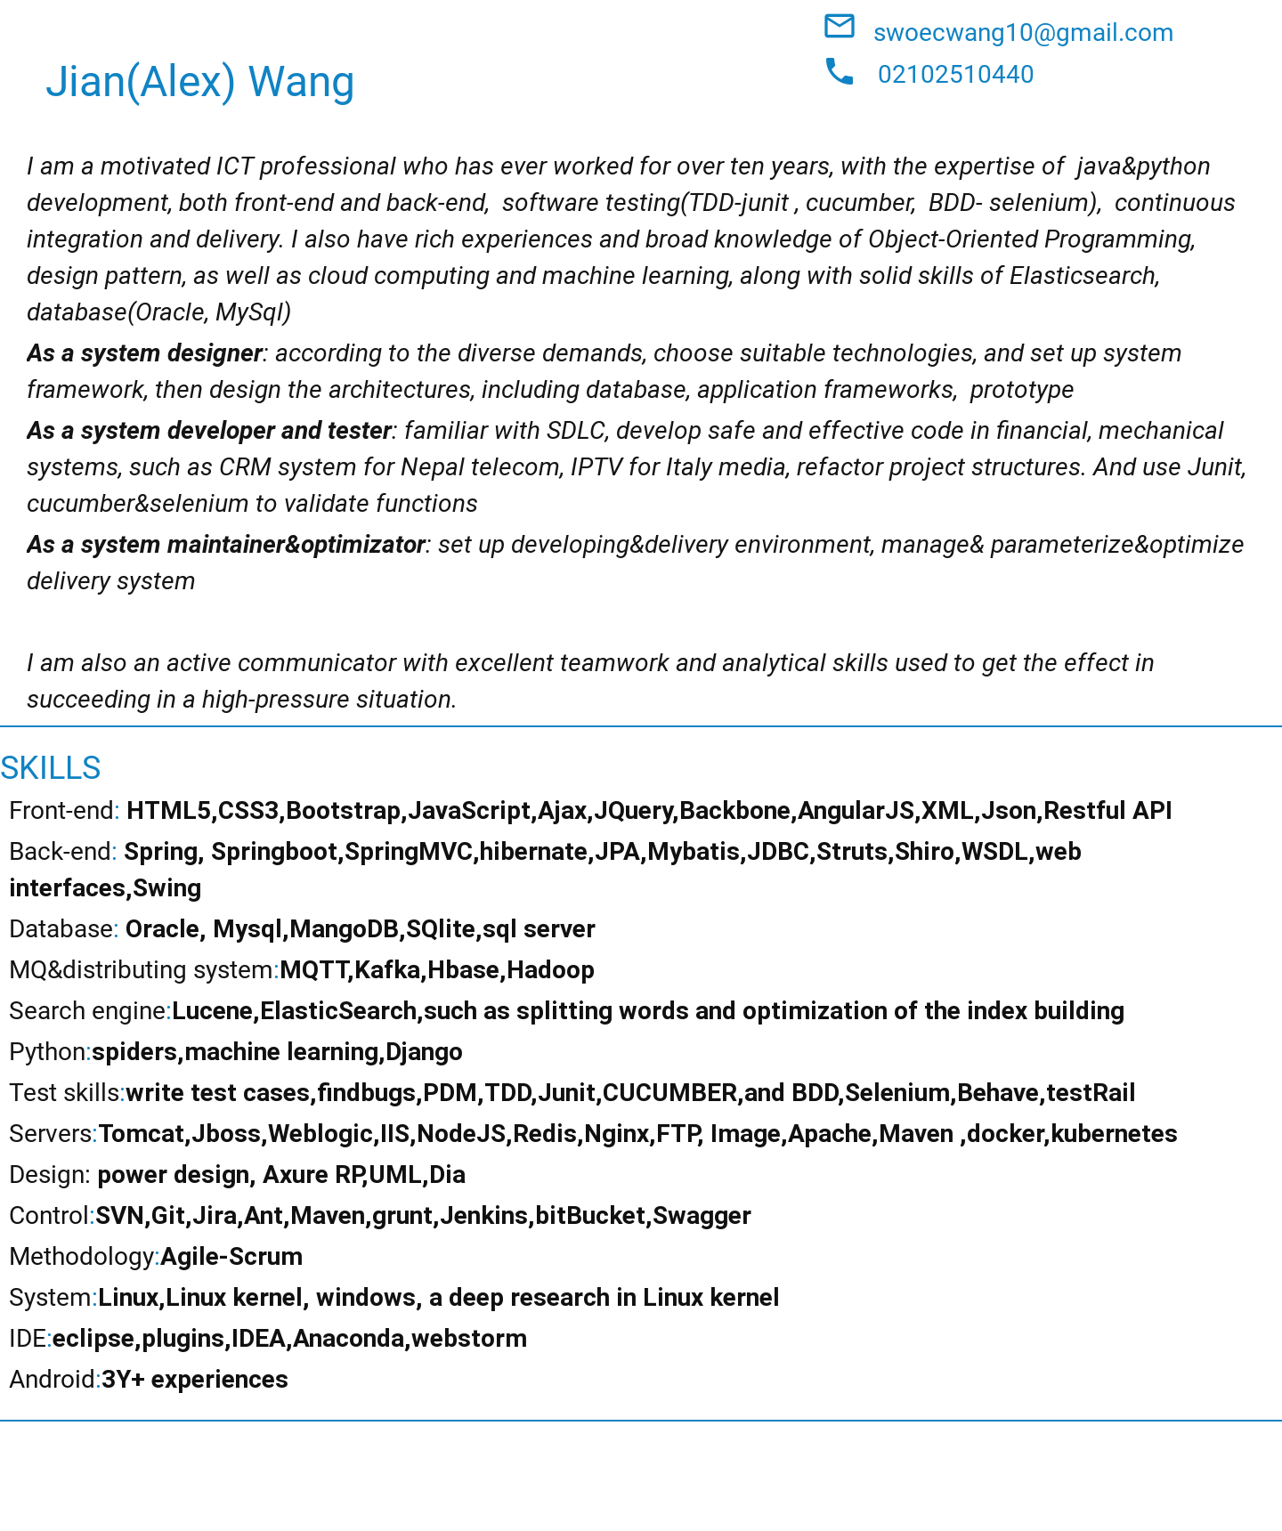

*LinkedIn:*[*https://www.linkedin.com/in/alex-wang-63237b39/*](https://www.linkedin.com/in/alex-wang-63237b39/)

*Github:*[*https://github.com/swoec*](https://github.com/swoec)

***PROFESSIONAL EXPERIENCE***

***Software developer XM developments 13/08/2018– Auckland***

*XM developments is a company working on e-commerce system and online stores*

***the platform is based on Java8, Jpa, spring-boot, Elasticsearch, Redis, test using behave, cucumber, Junit, Testrail***

***Git, Bitbucket , as well as docker, kubernetes.***

* *add new features to user groups: add new columns to the database(flyaway), upgrade models, and relative functions. Write the test case and test the new features(behave in python and Junit)*
* *Labels setting block: designed the label setting tables, designed the Rest APIs, developed all the functions(service, JPA, flyway), function test(behave in python), JUnit test, code review*
* *complete all the functions and Rest APIs,add new features added to the system*

***Team Leader &architect senior engineer Ligoo New Resource Co, LTD 02/2016-03/2018 Hefei***

*Ligoo New Resource is the second largest company building BMS for the electric vehicle as well as diverse services in China.*

* **Framework: the quick4j framework** 02/2016-03/2018
* Designed a safe framework supporting code-generating and page query in Mysql PostgreSQL and SQL server by integrating springMVC, JSP, jquery, Mybatis, Shiro, Bootstrap, CSS3, Html, maven, Jason

There are a lot of examples in the framework.

* This framework is used in financial firms and other companies to develop their own system and supply services for more than five million users, and 20 thousand users per second simultaneously online.
* **Project : DTU**  02/2016-03/2018 Platform: Linux

**Data Unify transmission system used on the electronic vehicles** includes three subsystems:

* Developed and tested new functions, continuously integreted and deployed new versions, costomizing the environments including database and deploy containers (on Redhat Linux) for Monitor Subsystem which is a Java web project based on Spring MVC, ibatis, JSP, Jquery, Bootstrap, and MySQL.
* Optimized the functions and added new functions for Data Transmission subsystem which is

a ruby server receiving the real-time data and using Fluentd to transmit them into MongoDB

* Developed Upgrade subsystem by using MQTT to upgrade the kernel of the battery control system and make the kernel more flexible. With the subsystem, the kernel and the parameters can be upgraded remotely, and bugs also can be fixed.
* Developed a simulate client and analysis the data collected by using python.
* Saved a lot of money(at least 2 M dollars every year) to maintain numerous users and respond quickly to users complaints.
* Won more attention and users as the system can help our customers to monitor their vehicles' status and get the vehicle’s situation even details, as well as to know the warnings and potential risks
* Successful to support 30 times growth a years.
* **Project: Real-time logistics and billing system** 11/2014-01/2016 Platform: Android
* Downloaded the bills from the server, and displayed the details of retail bills in the pad, when our Customers check in to the pad with ID card, system uploads the information to the server automatically When the GPRS or Wifi is available, otherwise storing the records in SQLite database The evaluation also can be implemented in the system by customers.
* Connected to the call system and sent short messages before their goods arrived.
* Plan the road which can save money, Monitor the vehicle speed and status
* Driving test for the system, customize and maintain the delivery environment
* Save 15% fares on gasoline every year Transportation rates 20% higher Save time for the users

Delivery service improved An annual award from the headquarters

* **Project: Website-zqxt** 03/2017–04/2017 **python**
* Developed a website to publish new information to the public, by using python Django, Nginx, MySQL, Memcached, published in BAE.
* This website has attracted more than 1 million users and gets a very high prize.
* **Project: spider** 10/2017–12/2017
* Developed a spider by using BeautifulSoup to collect users’information (username, tag, their friends) from zhihu.com, and store the data in MySQL, then to analyze their personalities and get the user portrait.
* **Project:.linkedin scraper** 03/2018-03/2018
* Developed a LinkedIn scraper by using Selenium, BeautifulSoup.The steps are 1.Login in LinkedIn by using selenium 2. Click the users' network 3. Click see all button 4. Get the page source and analysis to get their friend lists. 5. Get each friend link URL and their friends list
* This system helps me to get more information when I am looking forward and discover more opportunities. Boosted 500% faster than manual
* **Project: Elasticsearch tools** 01/2018-02/2018

Setup an ElasticSearch Cluster and index the data from MySQL database, and developed a search interface panel by using python.

* Search for massive data. 50% improvement to hit the target
* **Project:information-command system** 08/2016-08/2017

The system is using spring MVC, Kafka, Elasticsearch, as well as integrating many other products to build a platform to assist the police.

When a 111 call enters the platform, the system automatically searches all the relative pieces of information (identity, address, traveling information, and other types of information), according to the phone number, as well as the CCTV videos nearby, the location of the policemen, which all display on a map.

* Searched data from Elasticsearch cluster and displayed them on webpage

Using Kafka to exchange data and information with police officers from other provinces and central government.

* Drewing the prototype Design the system structure Set up the ElasticsSearch cluster
* Satisfy the security and speed demand Quick Search for massive data and get results (less than 1s)

Data exchange speed is 500 MB/S

* **Project: online stores** 08/2017-11/2017
* Developed an online store by using springMVC, hibernate, angularJS, MySQL, Bootstrap. the web site contains: client-side (goods-displaying, pursing workflow, payment, user interfaces) and administrator-side (managing goods, monitoring the risks)
* Response to massive requests from the million users every day and work smoothly, even a sudden flood in.
* **Set up and customize developing&delivery environment** Platform: Linux 02/2016-05/2016
* Set up maven server, Image server, Web server(Tomcat), SVN server ;

DB server: MySQL and backup, FTP server, Redis server

Integration developing tools: Eclipse with plug-ins, coding guideline

* The system framework which can deal with requests from quantities of users (more than 4.5 million), and flexible enough to upgrade for more users or even a sudden flood in.
* **project: online certification system** 02/2016-08/2016 Platform: Linux

This system is used to certificate their customers' quality to invest high-risk stocks and other products in a financial firm, by using spring MVC, hibernate, Shiro, MySQL, Redis, and FTP, CSS, bootstrap, js, as well as the quick4j framework

* Designed the DB structure using power design Designed the stereotype with Axure RP
* Developed user login interfaces and web pages, user register interfaces and web pages,

Message-sending interfaces via telecom systems, Online survey segment(interfaces and web pages), on-line certification segment(interfaces and web pages)

* User-friend system won high prizes from our customers Flexible framework to upgrade easily

Very fast to respond to massive requests(less than 1 second)

***Senior Software engineer Aisainfo-inc Global Delivery Service 06/2014—01/2016*****Nanjing**

*one of largest CRM software supplier in the world (NASDAQ: ASIA)*

* **Project: CRM system for Nepal Telecom** Platform：Window
* Developed functions for Nepal Telecoms, such as balance system, booking system, clients Package system by using spring, hibernate, jquery, JSP, Oracle, workflow, as well as Clarifying meta-data, to transform the functions into the plug-ins which can be plugged in other project
* developed file upload plug-in
* Support diverse demands from the users

Continuous integration and delivery when whatever happens(even a big earthquake)

***Senior Software engineer CITIC Department of venture Control 06/2012-06/2014* Nanjing**

*CITIC corp is the largest financial company in China and top 500 companies in the world.*

* **Project: Auditing platform** 06/2012---03/2013 Platform: Linux
* Developed the model-customizing tools for the bank (auditors can use it to develop their own model by setting their c parameters)

Developed the analysis tools to identify risks

Developed the task management tools (let auditors run their tasks automatically because it will cost a long time to analysis massive dates.), Data transferring (4T transaction records transferred into the platform)

* Customize the workshop and auditing tools 50% faster than previous systems

Get more project contracts from our customers

* **Project: Queue System in Bank** 03/2013-06/2014 Platform：Android
* Developed functions in the native model by using SQLite,socket server: such as:

To Display the customer’s information

To Classify the customers

To Assign a queue number for each customer

VIP service: with RFID, the system can identify our VIP customers when they enter the hall and display their information in the manager’s pad automatically, the manager assigns them to VIP rooms so the VIPs do not need to wait in the queue. The manager also can recommend special financial products to them based on their user portraits from their information analysis

* Improve the service quality 200% Better resource relocation

Saving money as more as 20 thousand dollars every year for every branch(more than 500 branches)

***Architect Compal R&D center 06/2010-2012*****Nanjing**

*The second-largest contract laptop manufacturer in the world, also top 500 companies in the world, headquarters is in Taipei, Taiwan, with offices in the People's Republic of China, South Korea, the United Kingdom and the United States*

As an Architect &Java engineer for pera project, developing a design system for an airplane, and a Lucene search engine, and provide the interfaces for web service using XFIRE and AXIS.

* **Project: Unitilies tools**  Platform：Android
* Refactor our android system to make it more smart and flexible. Developing new functions in the native model
* Flexible to reuse the functions Saving 200 people/month every year Codes became the assets
* **Project: Pera Platform** 06/2010-06/2012

A large design platform for giant Aircraft C919 and satellite by using spring, JDBC, JSP, Ajax, SVG, XFire, Axis, CSS

* Designed and developed a bus system (a key component), Provided interfaces and APIs for web service.

Set up a Lucene search engine for documents&files

* Build a new style system for designing and simulation based on new concepts and workflows

Help the designers to work fast(200% improvement)

Share designing experience Connect different systems to exchange data

A quick search engine on documents and more accurate to get

***Senior. Software Engineer ZTE 06/2008-05/2010*** **Nanjing**

*The fourth Largest mobile equipment manufacturer in the world, with offices in 180 countries.*

As a C& Linux kernel engineer, maintained Cloud Storage system to support new Businesses, such as: promoting activities and optimizing the system

Write reports to compare our product with several other cloud products

As a test engineer for disk for DIO, using: iozone, HDparm.

* **Project: Cloud storage system** Platform: Linux

Cloud storage system likes GFS, but more features

* Mainly developing fac&fas, using multi-thread, and IPC, message-queue, pre-read and so on. test and analysis the problems, and optimizing the system.
* Sold billions of US dollars every year

Supplies services for IPTV of Italy telecom, Vietnam telecom, China Telecom, and many other countries.

***Software Engineer Inspur 06/2006-06/2008*****Nanjing**

*one of the largest solution provider in the world*

As a java developer of the geographic information project, set up super-large search trees (more 100,000 leaves) and set up themes and special search based on java swing.

As a java developer for SIP, developed the data entry segment

* **Project: TACO** 06/2007-06/2008

TACO provided a full solution for Mercedes-Benz to resolve their problems on the budget, Souring, client relationship, and evaluation. It utilized Java, JSP, EJB, Hibernate, Struts, Ant, Display Tag, Commons-Net, HTML, JavaScript, PL/SQL, JUnit, WebLogic.

* Mainly on developing the functions and optimization of the system, and supporting the system,

Supported the QA to test the functions of the system

Resolved problems raised by project members and bug tracking

* Work effectively to deal with bugs Learning the test framework and automation test methodologies
* **Project: GIS**  11/2006-05/2007

Base on Java Swing with web start to publish and Informix as DB

* Added layers to map, and search on the map

Built a big search tree(more than 100000 leaves), and displaying search results in the Jtable, and Optimizing the layout

* 12600 times faster by using multithread to get massive data

* **Project: SIP** 06/2006-11/2006

The project is based on struts &ibatis, using Oracle.

* Developed the crucial functions, such as data entry with strict validation, the output of the Excel, as well as to upload the files to the warehouse.

Executed testing, detected and tracked bugs and writing Testing Reports

* Develop the key components(zero bugs) Learning the test methodologies

*Education: Computer Science Shandong University 2002 IBM DB2 International Certified (2006)*

**Referees**

available for requested